Lab: CI/CD to Azure Container Apps for a Node.js App (GitHub Actions)

What you’ll build?
A GitHub Actions pipeline that:
- installs & tests a Node.js app
- builds a Docker image
- pushes to Docker Hub
- deploys the image to Azure Container Apps (ACA)

At a glance (flow)
GitHub → Actions (build & test) → Docker image → Docker Hub → Azure Container Apps

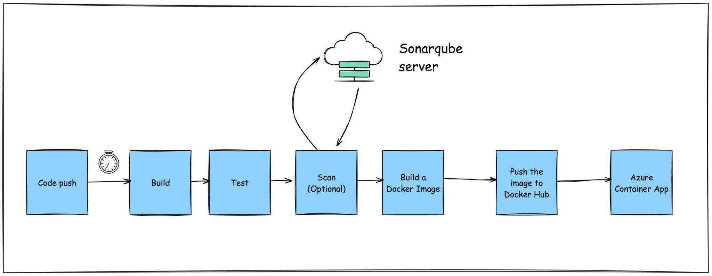

Prerequisites (checklist)
- GitHub account (you can fork the sample repo).
- Azure subscription (Owner/Contributor on the target RG).
- Azure Container Apps Environment already provisioned, plus a Container App created (empty/placeholder image is fine).
- Docker Hub account (repo created or permission to push).
- Node.js app with a package.json (tests optional).
- GitHub Secrets ready (you’ll add them in this lab).

Learning objectives
- Create a GitHub Actions workflow to build, test, and deploy a Node.js app to ACA.
- Publish the Docker image to Docker Hub using tokens.
- Validate the deployment and read logs from ACA.
- (Stretch) Use OIDC in place of client secrets; add health checks and autoscaling.

Before you start (one-time Azure setup)
If ACA is already created, you can skip to Step 1.
# Variables (edit these and append your name)
RG=container-labs-rg
LOC=westeurope # pick your region
ENV_NAME=aca-env
APP_NAME=frontendapp
PLACEHOLDER_IMAGE=nginx:alpine # temporary image until CI/CD pushes yours
# Create Resource Group
az group create -n $RG -l $LOC
# Create Container Apps Environment
az containerapp env create -g $RG -n $ENV_NAME -l $LOC
# Create a Container App with public ingress (port 3000 for Node apps)
az containerapp create -g $RG -n $APP_NAME \
--environment $ENV_NAME \
--image $PLACEHOLDER_IMAGE \
--ingress external --target-port 3000 \
--query properties.configuration.ingress.fqdn -o tsv
Keep the resulting FQDN handy—you’ll use it to test after deployment.

Step 1 — Get the code
- Fork the sample Node.js repo
- Clone your fork locally.
If the repo doesn’t have a Dockerfile, add the simple one below.
# 1. Build stage
FROM node:22-alpine AS build
WORKDIR /app
COPY package*.json ./
RUN npm ci
COPY . .
# If you have a build step (e.g., React/Next client): npm run build || true
RUN npm run build || true
# 2. Runtime stage
FROM node:22-alpine
WORKDIR /app
ENV NODE_ENV=production
COPY --from=build /app ./
EXPOSE 3000
CMD ["npm", "start"]

Step 2 — Create GitHub Actions workflow
Create folder and file:
.github/workflows/ci.yml
Paste this workflow:
You can also download the workflow from here - Pipeline Solution

name: Build, Test, and Deploy to Azure Container Apps
on:
# Manual trigger from the Actions tab
workflow_dispatch:
permissions:
contents: read
actions: read
checks: write
pull-requests: write
# If you plan to switch to OIDC later, keep id-token: write
id-token: write
jobs:
build-test-and-deploy:
runs-on: ubuntu-latest
environment: dev
steps:
- name: Checkout code
uses: actions/checkout@v4
- name: Setup Node.js
uses: actions/setup-node@v4
with:
node-version: 22.x
cache: npm
cache-dependency-path: package-lock.json
- name: Install dependencies
run: npm ci
- name: Run unit tests (if present)
run: npm test --if-present
- name: Build the application (optional)
run: npm run build 2>/dev/null || echo "No build step; continuing."
- name: Azure Login (Service Principal)
# If you adopt OIDC later, switch to federated creds and drop client-secret
uses: azure/login@v2
with:
client-id: ${{ secrets.AZURE_CLIENT_ID }}
tenant-id: ${{ secrets.AZURE_TENANT_ID }}
subscription-id: ${{ secrets.AZURE_SUBSCRIPTION_ID }}
client-secret: ${{ secrets.AZURE_CLIENT_SECRET }}
- name: Build, push image to Docker Hub and deploy to ACA
uses: azure/container-apps-deploy-action@v2
with:
appSourcePath: ${{ github.workspace }}
# Uncomment if your Dockerfile isn't at repo root
# dockerfilePath: ./Dockerfile
# target: <multi-stage-target-name-if-any>
registryUrl: docker.io
registryUsername: ${{ secrets.DOCKERHUB_USERNAME }}
registryPassword: ${{ secrets.DOCKERHUB_TOKEN }}
# Azure targets
resourceGroup: container-labs-rg
containerAppName: frontendapp
# Image tag = commit SHA for traceability
imageToBuild: ${{ secrets.DOCKERHUB_USERNAME }}/frontendapp-node:${{ github.sha }}

Step 3 — Add required GitHub Secrets
In GitHub → Settings → Secrets and variables → Actions (repo level), add:
Azure
- AZURE_CLIENT_ID
- AZURE_TENANT_ID
- AZURE_SUBSCRIPTION_ID
- AZURE_CLIENT_SECRET
Docker Hub
- DOCKERHUB_USERNAME (your Docker Hub handle)
- DOCKERHUB_TOKEN (a Personal Access Token with write:packages or repo push)
Ensure your Docker Hub repo exists, or Docker Hub will create it on first push if your account settings allow.

Step 4 — Run the pipeline
- Commit & push the workflow file.
- Go to Actions → Build, Test, and Deploy to Azure Container Apps → Run workflow.
Expected outcomes:
- Tests pass.
- Docker image appears in Docker Hub as
${DOCKERHUB_USERNAME}/frontendapp-node:<commit-sha>.
- ACA revision updates to the new image.

Step 5 — Verify deployment

Get the public URL (FQDN) again
az containerapp show -g container-labs-rg -n frontendapp \
--query properties.configuration.ingress.fqdn -o tsv

Hit the app
# Replace with your FQDN
curl https://<your-app>.region.azurecontainerapps.io

You should see your app’s HTML response.

